Database Management System – cs422 DE
Assignment 5 – Week 6
------------------------------------------------------------------------------------------------------------------------------------------
This assignment is based on lecture 6 (chapter 12).
- Submit your own work on time. No credit will be given if the assignment is submitted after the due date.
- Note that the completed assignment should be submitted in .doc, .docx, .rtf or .pdf format only.
- In MCQs, if you think that your answer needs more explanation to get credit then please write it down.
- You are encouraged to discuss these questions in the Sakai forum.

- A student can take not more than 5 subjects in a semester. The number of students allowed in a subject in a semester is not more than 40. The student – subject relationship is:
(A) 5:40 (B) 40:5
(C) N:5 (D) 40:M
ANS: D

- Which of the following is NOT a basic element of all versions of the E-R model?
(A) Entities
(B) Attributes
(C) Relationships
(D) Primary keys
ANS: D

- The attribute name could be structured as a attribute consisting of first name, middle initial, and last name. This type of attribute is called
(A) Simple attribute
(B) Composite attribute
(C) Multivalued attribute
(D) Derived attribute
ANS: B

- Which of the following indicates the minimum number of entities that must be involved in a relationship?
(A) Maximum cardinality
(B) Minimum cardinality
(C) ERD
(D) Keys
ANS: B

- Which of the following is a single valued attribute
(A) Register_number
(B) Address
(C) SUBJECT_TAKEN
(D) Reference
ANS: A

- In a one-to-many relationship, the entity that is on the many side of the relationship is called as
(A) Strong entity
(B) Weak entity
(C) Entity that has optional participation in the relationship
(D) Entity that has mandatory participation in the relationship
ANS: B

- Describe what attributes represent in an ER model and provide examples of simple, composite, single-valued, multi-valued, and derived attributes.
(Review Question 12.3 in 5th edition/ 11.3 in 4th edition)
ANS: In an Entity-Relationship (ER) model, attributes represent the properties or characteristics of entities or relationships. They help describe the data stored in the database for each entity instance. These attributes play a crucial role in defining the structure and integrity of data in an ER model.

Simple attribute: An atomic value that cannot be divided further.
Example: age, salary, student_id

Composite attribute: An attribute made up of smaller subparts.
Example: name can be divided into first_name, middle_name, and last_name

Single-valued attribute: Holds only one value for a particular entity.
Example: email, SSN, birth_date

Multi-valued attribute: Can hold multiple values for a single entity.
Example: phone_numbers, languages_known

Derived attribute: Its value can be derived from other attributes.
Example: age can be derived from birth_date, total_price can be derived from unit_price × quantity

- Describe how strong and weak entity types differ and provide an example of each.
(Review Question 12.8 in 5th edition/ 11.8 in 4th edition)
ANS:
Strong Entity Type:
A strong entity has a primary key that uniquely identifies each instance. It is independent and does not require any other entity for identification.
E.g: Employee(employee_id, name, department)
Here, employee_id is a unique identifier. Each employee exists independently.

Weak Entity Type:
A weak entity cannot be uniquely identified by its own attributes alone. It depends on a strong entity for its identification. It has a partial key, and the full identification is made by combining this with the strong entity’s key. It typically has a total participation in an identifying relationship.
E.g: Dependent(dependent_name, relationship, employee_id)
Here, dependent_name alone isn’t unique. It needs employee_id from the Employee entity to form a unique identifier.

- Create an ER diagram for each of the following descriptions:
(Exercise 12.10 in 5th edition/ 11.10 in 4th edition)
  - Each company operates four departments, and each department belongs to one company.
ANS:
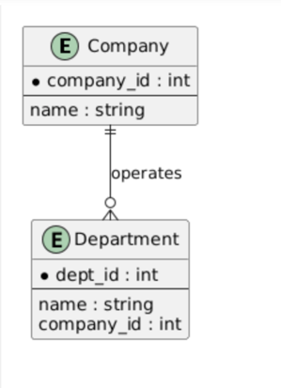
  - Each department in part (a) employs one or more employees, and each employee works for one department.
ANS:
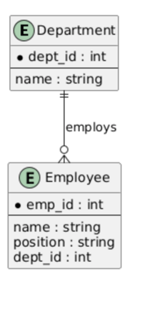
  - Each of the employees in part (b) may or may not have one or more dependants, and each dependant belongs to one employee.
ANS:
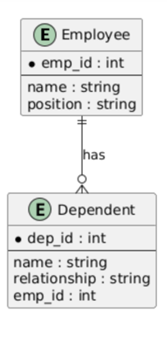
  - Each employee in part (c) may or may not have an employment history.
ANS:
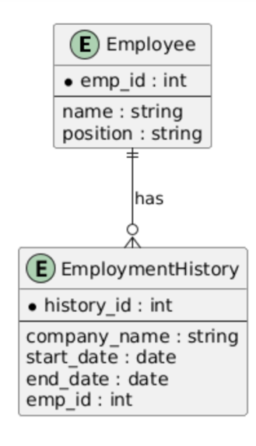
  - Represent all the ER diagrams described in (a), (b), (c), and (d) as a single ER diagram.
ANS:
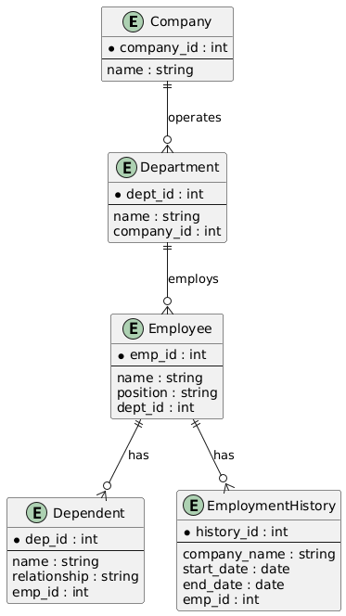

- Solve exercise 12.12 from the 5th edition (11.12 from the 4th edition). If time permits, solve from a-f. Otherwise, it’s ok if you just solve f.
ANS:

